
YEAR 12 WORK EXPERIENCE PLACEMENTS
A GUIDE FOR PARENTS 2024

In the Summer Term your child will be completing one week’s compulsory work experience. This is an educational activity planned to increase pupils’ awareness of the real world of work. The following guide explains the aims and learning outcomes, details regulations for work experience and clarifies what your child needs to do next.

The Aims of work experience are:
- To provide an experience of the real world of work.
- To help pupils understand and develop the key skills and personal qualities which are sought by employers.
- To ensure that our pupils are well prepared for the adult working environment.
- To help students understand the relevance of school to future work and learning.
- To improve the employability of the pupils.
- To help pupils make informed decisions about their future careers.
- To develop maturity and self-confidence.
- To raise pupils career aspirations.

The Key Learning Outcomes:
Pupils will be presented with many learning opportunities throughout their placement. In addition they will be able to:
- Identify, understand develop and assess the key skills and attitudes they need to survive in the world of work.
- Identify differences between school and the world of work.
- Identify and understand the importance of Health and Safety issues.
- Improve their interview technique.
- Understand the concept of Equal Opportunities.
- Learn about the many opportunities available to them in the future.

IMPORTANT INFORMATION
Please read the following information and ensure that you and your child are familiar with the regulations surrounding their work experience.

Health and Safety
ONLY PLACEMENTS WHO HAVE COMPLETED ALL STAGES OF THE UNFIROG PLACEMENT TOOL CAN GO AHEAD. Children are seen as being particularly at risk because of their inexperience and immaturity. Understandably, schools are required to exercise a duty of care when students are in school or taking part in school activities like work experience. As part of the PSHE programme involving planning for work experience pupils are given information of the importance of Healthy and Safety within the workplace.

Insurance
In the UK and in many other countries, students on work experience placements are treated as employees of the employer for the purposes of insurance. Because of this, to host work experience, most employers must have appropriate Employer's Liability Insurance.
The main thing to be careful of is whether the Employer's Liability insurance covers young people who are less familiar with workplaces. The employer should check their policy documentation to ensure that they are adequately covered; when in doubt, they should contact their insurer or the broker who arranged the policy.

Separately, the employer may have a Public Liability insurance policy, which is not a legal requirement to host work placements, and it will not cover students themselves when they are at the placement.

Nonetheless, most Public Liability policies will cover any accidental injury or damage to third party property arising from the actions of the student on work experience, and many employers want to make sure that they are insured in this way. Employers should check their Public Liability insurance policy document, and if they are in doubt, contact their insurer or the broker who arranged the policy.
In the UK these sorts of employers are exempt from needing Employers' Liability Insurance:
Sole traders, and companies employing only their owner where that employee also owns 50% or more of the issued share capital in the company;
- Most public organisations including government departments and agencies, local authorities, police authorities and nationalised industries;
- Health service bodies, including National Health Service trusts, health authorities, primary care trusts and Scottish health boards;
- Some other organisations which are financed through public funds, such as passenger transport executives and magistrates’ courts committees;
- Family businesses, i.e. if all of your employees are closely related to you (as husband, wife, civil partner, father, mother, grandfather, grandmother, stepfather, stepmother, son, daughter, grandson, granddaughter, stepson, stepdaughter, brother, sister, half-brother or half-sister). However, this exemption does not apply to family businesses which are incorporated as limited companies.
On the Unifrog Placements tool, for an in-person placement:
- If the employer fits into one of the special categories above, the tool asks the Employer placement lead what insurance, if any, the employer does have in place
- Otherwise the tool asks employers to give details for their Employers' Liability Insurance, including sharing with the school / college a copy of their insurance certificate. If this will have expired before the end date of the placement (or a day after the start date if the placement is marked as ‘ongoing’), then the Employer placement lead must commit to updating the insurance details before the start of the placement. The system also sends the employer a reminder email to update their insurance details on the day they've said that their insurance will expire.
Risk Assessments
In a Risk Assessment an employer must:
- Identify what in the business could cause injury or illness (the hazards);
- Decide how likely it is that someone could be harmed and how seriously (the risk);
- Explain how the employer minimises the hazards, and how they control the risks.
In the UK companies with fewer than 5 employees don't legally need to have a written Risk Assessment, though it is good practice to have one. And even though it doesn't legally need to be written down, Employers should still have gone through the process of assessing risks, and considering what steps to take to mitigate the risks they identify.
It is wholly up to the employer to create a suitable Risk Assessment - they are the ones who are responsible for the wellbeing of their employees (including students on placements), and they are the ones who understand the risks encountered at their workplace. It's not the role of the school, parent / guardian or student to ‘sign off’ on the Risk Assessment.
When an employer is hosting a young person on a placement, they should check that their Risk Assessment sufficiently takes into account having a young person on site, who might be less familiar with workplaces. This doesn't mean that the Risk Assessment needs to specifically mention young people, but there might be additional risks or actions that employers need to take to ensure that everyone at the workplace remains safe.

If you are arranging a private placement with a family member who has less than five employees you must contact Mrs Knight directly.

Safeguarding
Page 81 of DfE's Keeping Children Safe in Education 2022 states as follows:

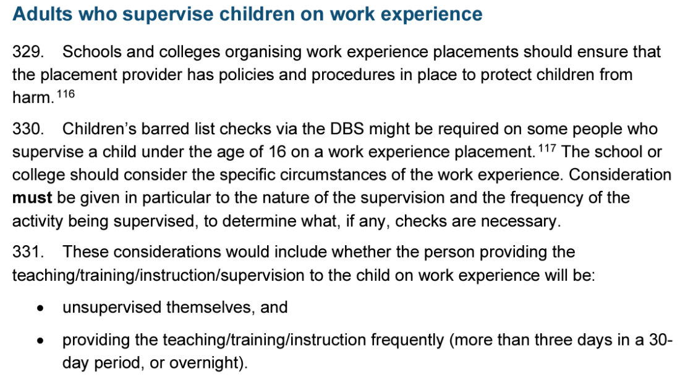
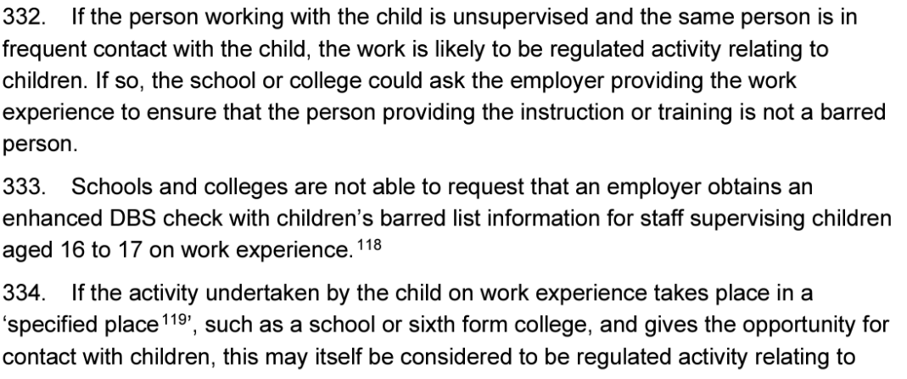
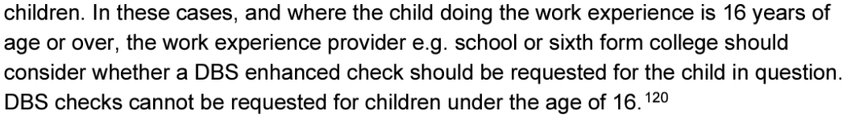

Work Experience placements over the age of 16

For Year 12 Students on work experience placements, section 333 of the Keeping Children Safe in Education 2022 Statutory Guidance states that if the student is 16 years of age or older, the school cannot request a DBS check of the employer regardless if the two scenarios mentioned above are true.

Therefore, if the adult supervising the student on a placement will be alone and unsupervised AND the placement is longer than 3 days, we will discuss the placement with the Parent / Carer and ultimately the permission for the placement to go ahead will be down to the parent/carer.

Health and Medical
It is important that the school and employers are aware of any health or medical issues which may affect the pupil during their placement. You have the opportunity to let your placement know of any medical issues when completing the Placement section on Unifrog.

Travel
Pupils will be expected to cover their own travelling expenses to their placement.

Pay
No payment should be made. The work experience programme is part of the pupils’ education and does not constitute employment. Any payment invalidates the insurance cover.

Hours
Pupils will be expected to fit in with the general hours of work at their placement. This may not fall within their normal ‘school’ hours.

Timekeeping and attendance
Pupils should attend for the whole week and should arrive punctually each day for work. If for any reason a pupil is to be absent or late it is the pupil’s responsibility to notify both the employer and the school of the reason why. Failure to do so will result in the pupil being recorded on the register as unauthorised absence. Mrs Knight, Careers Leader, can be contacted by telephoning 01279 654901 ext. 258 or emailing info@stmarys.net.

Dress Code
Pupils are expected to dress appropriately for the environment in which they are working. Information about the dress code or special protective clothing for Health and Safety purposes will be included in the details provided by the employer on the placement sheet.

Interviews
ALL pupils are expected to arrange an interview with their placement supervisor 6-8 weeks before the placement commences. Pupils must notify the Mrs Knight when this interview is going to take place. Pupils must only use their school email and only give the school address for correspondence.

Student Preparation for Work Experience
During dedicated careers PSHE lessons, the students will have more information about what is expected of them during work experience including a lesson on Behaviour within the Workplace.

Work Experience Journal
Pupils will be asked to download and complete a Work Experience Journal which they will be expected to complete on a daily basis during their placement. There will be a section for employer and parent comments.

Reflection
In addition to the pupils Work Experience Journal, they will need to complete a Student Reflection Form on their Unifrog account. The Employer is also invited to complete a Reflection form where they can provide feedback.

WHAT NEXT?

- Year 12 Assembly
All year 12 pupils will have an assembly about their work experience. Pupils will get the opportunity to hear from students who attended work experience in the past.

- Provide Parental Consent
Pupils CAN NOT take part in Work Experience without parental consent. You will be contacted by Unifrog to give parental consent to the work experience taking place. If you do not complete this, your child will not be able to participate. See number iii. Under Unifrog for more details.

- Source a placement
Pupils are actively encouraged to find their own placements within specialised workplaces or geographical areas. Students will need to contact employers directly requesting a work experience placement for the week of July 3rd 2023. Students are encouraged to email or telephone employers explaining why they would like a work experience placement there and why it would benefit them.

Private Placements

It is important to note that private placements may not be guaranteed for several reasons; including health and safety, police records or an inappropriate workplace. All placements will need to undergo Health and Safety checks. Details regarding the necessary work placement forms will be issued shortly. The deadline for private placements is Friday 19th April 2024.

- Tips on sourcing a placement

- Encourage your son/daughter to look for their own placement
- Persevere! You may not get the first placement you approach, you may have to apply for a few! Keep searching until you get one.
- Go it alone – it is best if student’s search for placements independently and not with a friend as employers are less keen to take students in pairs/groups.
- Think about the location of the placement, the cost of travel and how you will get there.
- There are various ways to search for a placement: by foot, internet search, asking friends & family, by phone or by email / sending a letter.

- Unifrog

All placements will be uploaded on to the pupil’s Unifrog account. Once the placement has been confirmed the following course of action will take place:

- Student uploads / inputs Work Experience Placement Info
- Unifrog contact the Employer Placement directly with a form to complete. This form will detail the employers contact details, details of working hours, location, contact information, Liability Insurance details, Risk Assessment information and whether the pupil will be alone with one member of their staff. If this box is flagged up, DBS searches will be required to be evidenced.
- Once the Employer Placement has filled in their form, Unifrog will email the parent/carer for their consent to allow the placement to go ahead. Parents/carers will be able to view all of the information completed by the employer.
- Once the parent/carer has given their consent for the placement to go ahead, Mrs Knight, Careers Leader will review the information provided and give permission for the placement to go ahead. We will check that all Employer Liability Insurance is in place and is up to date, that any necessary Risk Assessments or DBS certificates are in place.
- Students are then encouraged to arrange an interview with their employer 6-8 weeks before their placement.
- Unifrog will send 2 emails at different stages to all key people; Pupil, Parent, Employer and School with a reminder of the placement before the event.

- Responsibility
The employer will have primary responsibility for the pupil whilst they are in their work experience placement. From a legal perspective students on work experience placements are generally considered the same as normal employees and are therefore covered by the employer’s health and safety policies and insurance policies. The role of the school is solely to take reasonable steps to ensure that the employers is acting responsibly. Parents / guardians of students under 18 need to agree to the student going on a placement.

The Unifrog Placements tool is a series of forms that lets schools and other educational providers check that the employer has the necessary insurance and policies in place. It also gives employers guidance to help them run a great placement for the pupil and to make sure that their insurance and policies are up to date and are appropriate. The Unifrog platform also makes it easy for a parent / guardian to agree to the placement.

Placements with Family Members

If a student plans to undergo their work experience with a family member (e.g. a parent or uncle) then the school still has the same duty of care that they would if the student were doing a placement with anyone else. The duty of care is to take reasonable steps to satisfy themselves that the host is acting responsibly, with appropriate insurance, Health and Safety policies, and Risk Assessments in place.

If a placement is with a family member, there are sometimes some confusing elements:

- Employers Liability Insurance – sometimes people think that if a family member is hosting a placement, there is no need for the employer to have Employers Liability Insurance. It's true that in the UK, family businesses where all the employees are closely related don't need ELI - however, firstly this exemption does not apply to family businesses which are incorporated as limited companies, and secondly almost any other sort of company does need to have ELI, even if the host is a family member of the student. Sometimes people think that if a family member is hosting a placement, there's no need for the employer to have Employers' Liability Insurance.
- Health & Safety policy, Risk Assessment, Safeguarding - For these things, when a family member hosts a placement, there are no differences from any other type of placement, including when the placement is at a family businesses.
I hope that this guide gives you all of the information you require about work experience this year.

Please feel free to contact me by emailing info@stmarys.net if you have any further queries.

Kind Regards,
Mrs Joanna Knight
St Mary’s Careers Leader

